|  |  |  |  |
| --- | --- | --- | --- |
| Angol szóbeli vizsga | Középszint | 1.Vizsgafeladat | Bevezető interjú |

**1. Vizsgafeladat -vizsgáztatói példány**

**Bevezetés (nem értékeljük)**

Mielőtt a tényleges szóbeli vizsga elkezdődik, egy rövid (kb. egyperces) bemelegítő beszélgetés szükséges.

Vizsgáztató:

* Did you sleep well?
* How are you today?
* What did you do yesterday evening?
* When did you get up?
* Is it the first time you are taking an exam?
* How did you come here?
* Are you planning to have a party after the exam?
* ( If “no”: ) What are you going to do after the exam?

Now I am going to ask you a few questions. If you can’t understand me, I can repeat the question once. Let’s get started:

**Tényleges vizsga (ettől a résztől értékeljük):**

Vizsgáztató:

We are going to talk about housing.

A Could you describe your house or flat?

**I live in a … There are …rooms. There is a .., a… , a… There are 2 bedrooms. There is a garden, a ….**

B What other forms of housing do you know? What are they like?

**There are terraced houses, skyscrapers, boat houses. People can live in a lighthouse. It can be very exciting to live there.**

C How do you share chores at home? What housework do you do?

**My mother does most of the housework. She cleans the house, does the ironing, the shopping. She cooks every day.**

**My father washes the car, he changes the bulbs, cuts the grass.**

**I …**

Thank you very much.

That’s the end of your first task.

|  |  |  |  |
| --- | --- | --- | --- |
| Angol szóbeli vizsga | Középszint | 2.Vizsgafeladat | Szituációs feladat |

# 2. Vizsgafeladat - vizsgáztatói példány

A vizsgáztató átadja a vizsgázónak a vizsgázó feladatlapját. A vizsgázó kb. fél percig készülhet.

A vizsgázó példánya

You are planning to have a New Year’s Eve party.

Discuss the following points with your examiner:



- How many people should you invite?

- Where should you have the party?

- What food and drinks should you serve?

- How long should it be?

- How many people should you invite?

- **We should invite …people.**

- Where should you have the party?

**- We should have the party at home. If the weather is nice, we could stay in the garden.**

- What food and drinks should you serve?

- **We should serve …**

- How long should it be?

**- It should start at … and finish at …**

Prompts for the interlocutor:

* Do you think you can afford it?
* What will you eat and drink?
* Are you going to invite your parents?
* Isn’t that a bit late?

|  |  |  |  |
| --- | --- | --- | --- |
| Angol szóbeli vizsga | Középszint | 3.Vizsgafeladat | Önálló témakifejtés |

#### **3. Vizsgafeladat - vizsgáztatói példány**

A vizsgáztató átadja a vizsgázónak a vizsgázó feladatlapját. A vizsgázó kb. fél percig készülhet.

# A vizsgázó példánya

These two pictures show everyday objects.

- How often do you use them?

- What do you use them for?

- Which is ideal for teenagers?

- Which is more popular with teenagers?

**I can see a smart phone and a bicycle in the 2 pictures.**

**I have a ..Samsung.. smart phone and I have a bike, too.   
I use my phone every day, I spend a lot of time using it. I like cycling, I go to school by bike. / I don’t have a bike. / I don’t like cycling.**

**I usually chat with my friends, I use different social networking sites, I watch videos, listen to music…. I often go cycling with my friends. I sometimes go for longer distances as well.**

**I think smart phones are good for teenagers because they can get a lot of information if they have Internet access. If they want to do some sports, it’s OK if they ride a bike. It can be a lonely activity and an activity with friends.**

**I think smart phones are more popular than bikes. In my opinion teenagers use their smart phones a lot.**

Prompts for the interlocutor:

* What does it look like?
* Is it special to you? (birthday present, the first one, etc.)
* When you buy them, do you look for a certain brand?
* What else can you use a mobile phone for?

**THANK YOU, THIS IS THE END OF YOUR EXAMINATION.**

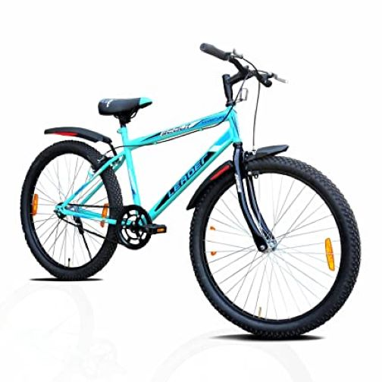

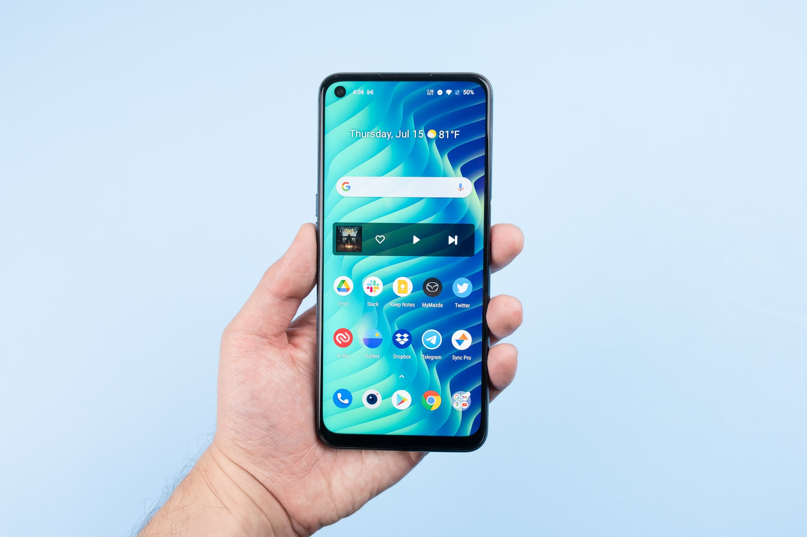

|  |  |  |  |
| --- | --- | --- | --- |
| Angol szóbeli vizsga | Középszint | 2.Vizsgafeladat | Szituációs feladat |

# 2. Vizsgafeladat - vizsgázói példány

A vizsgázó példánya

You are planning to have a New Year’s Eve party. Discuss the following points with your examiner:

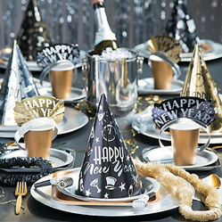

- How many people should you invite?

- Where should you have the party?

- What food and drinks should you serve?

- How long should it be?

|  |  |  |  |
| --- | --- | --- | --- |
| Angol szóbeli vizsga | Középszint | 3.Vizsgafeladat | Önálló témakifejtés |

#### **3. Vizsgafeladat - vizsgázói példány**

# A vizsgázó példánya

These two pictures show everyday objects.

- How often do you use them?

- What do you use them for?

- Which is ideal for teenagers?

- Which is more popular with teenagers?

**

